**School Uniform**

Thank you to everyone who returned the uniform survey this week. The unanimous decision was to adopt the following uniform for every day of the week:

[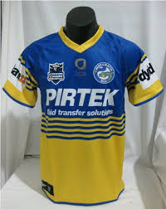](http://www.google.com.au/imgres?q=parramatta+eels+jersey&safe=active&hl=en&biw=1600&bih=806&tbm=isch&tbnid=vmAlLJbNCcoFSM:&imgrefurl=http://www.newrugbykits.com/2012/03/new-parramatta-eels-heritage-jersey-2012/&docid=mKMNe0GXyvwfsM&imgurl=http://www.newrugbykits.com/wp-content/uploads/2012/03/Parramatta-Eels-Heritage-Jersey-2012-Jumper.jpg&w=552&h=696&ei=PXmqUvTqDo3YlQWMyYCIDg&zoom=1&ved=1t:3588,r:75,s:0,i:314&iact=rc&page=3&tbnh=184&tbnw=146&start=72&ndsp=34&tx=81&ty=76)

JUST KIDDING!

THIS IS IT!

Our new micro-fibre royal blue with yellow inserts shirt is the chosen school uniform shirt for boys and girls. These are available at the office for $20 each. Rhonda has placed another order which will hopefully be here in February. Royal blue shorts or skirt will be worn with the shirt each day although grey shorts are also acceptable.

Our current (old) school uniforms can be worn until children grow out of them or they wear out.

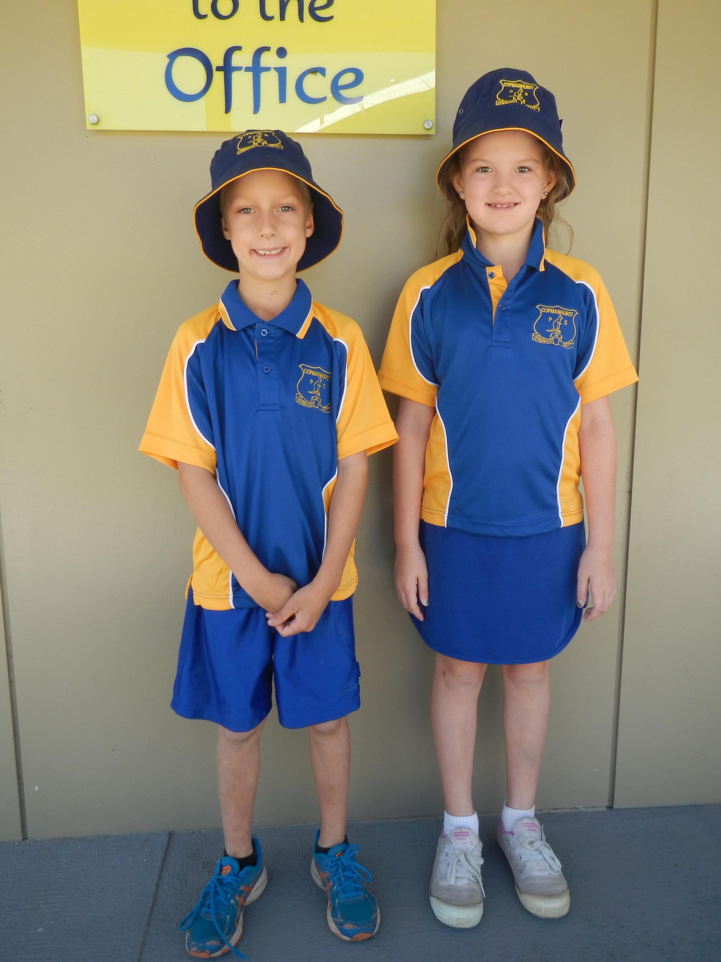

Don’t forget it’s Activities Week next week. No school uniform. Water slide on Tuesday (towel, change of clothes). Ulmarra Pool day Wednesday – please return permission note. No cost. Food provided.